


Creating a balanced digital diet
- Lead by example: Just like anything, children copy their parents’ actions and behaviour. If you set boundaries for your own screen, it will be easier for your kids to do the same.
- Set boundaries WITH your kids: Get them involved in the process of how long they can spend online, at what times and on which platforms. Set up screen-free times or rooms where screens are out of sight, so out of mind. Review these as they get older, encouraging more personal responsibility.
- Ensure a healthy mix of screen activity: Make sure they have a good balance of screen activities that encourage creativity, learning & education, connecting with family & friends, as well as using devices for passively engaging with content.
- Avoid using screen time as a reward: This will elevate the status of screen time above other activities and may encourage children to simply want more.
- Physical activity and sleep are vital: Make sure screens are not displacing these things by keeping screens out of bedrooms at bed time and that you are creating opportunities for your children to be active each day.
Screen Time: Parent Guide



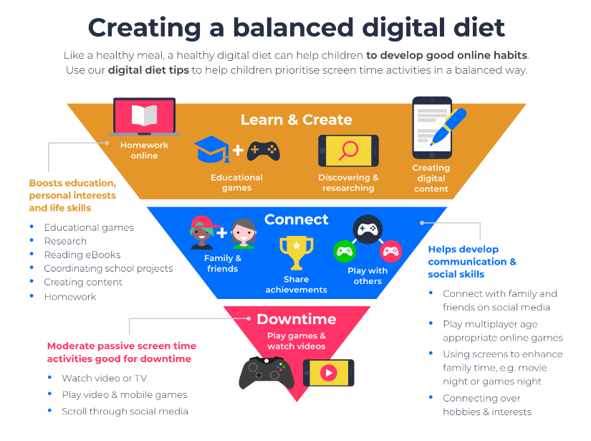
As screens become a bigger part of young children’s lives at home and at school, it’s important to put balance and purpose behind screen time.
Taken from the online guides on Internet Matters this booklet is aimed at providing some information on screen time as well as tips to support their use.
.



Screen Time Tips & Support
Internet Matters, have created these handy video guides to support families with talking about screen time.
EYFS: https://youtu.be/zBxQJE_H20Y
Key Stage 1: https://youtu.be/J03FF9K9Bf0
Key Stage 2: https://youtu.be/B7pJrdRzwF0

Managing children’s screen time
Parental controls can support positive screen time - Make use of parental control tools on the devices and platforms your child uses. Some controls can remotely close down apps or games, reminding your child when they reach daily agreed limits. Others have night settings, which slowly reduce the amount blue light given off by the screen during evenings. This can help children wind down before bed.

4 tips to help make the most of screen time
- Agree on boundaries - Every child’s screen time needs is different. Do they need their device to complete school work? Does their time online negatively affect their mood? With your child and whole family, create a family agreement that outlines when, where and for how long you all can use devices. And make sure everyone in the family gets on board — including older siblings, grandparents and anyone else living in the home.
- Set up parent controls - Screen time parental controls come in a range of shapes and uses. Google Family Link for example, can provide screen time reports across apps and devices. On some social media sites, you can monitor screen time through Family Pairing or set daily limits on your child’s account. These parental controls cannot replace regular conversations. However, they can support what you and your child agrees on when it comes to setting boundaries. Internet Matters has a number of how to’s: Parental controls & privacy settings guides | Internet Matters
- Talk regularly about device use - As soon as your child starts using devices, talk to them about their time online. Ask them questions about how their time online makes them feel and check in on the actions they take to decompress. In your conversations, you can also revisit the Family Agreement to see what is or isn’t working
- Find activities to do during screen breaks When it comes to screen breaks, make sure children have something else they can do. Maybe that’s writing stories or making crafts or playing outside. Often, complaints around device breaks relate to ‘boredom’ or not knowing what else to do. If screen time breaks are new, this is especially important. Try doing new things together at first to help children find different options.

