

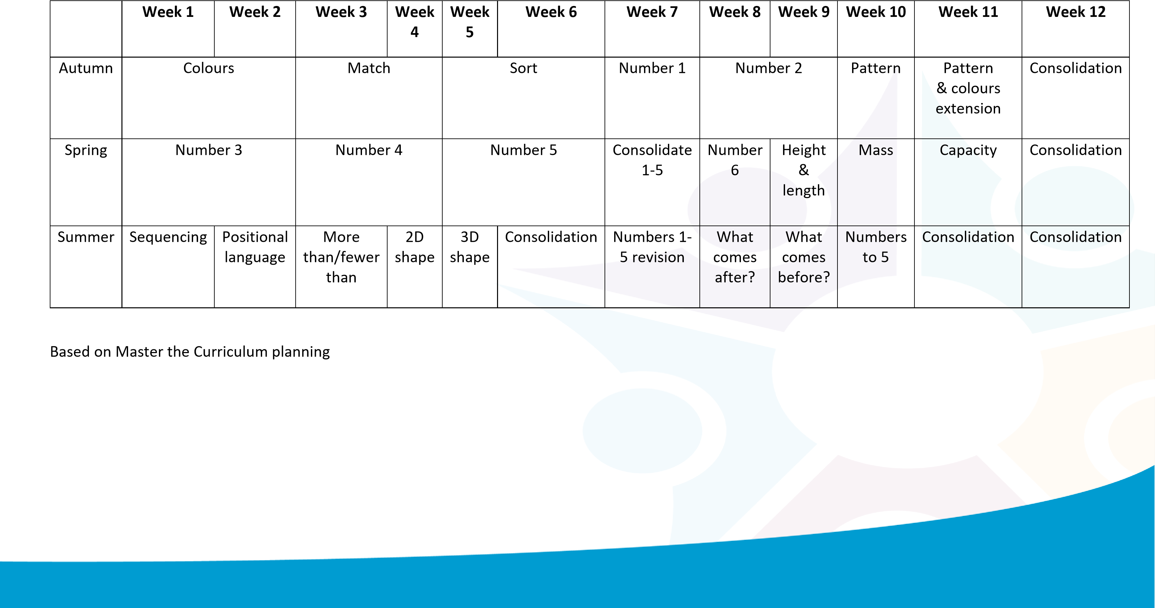

Nursery Maths Long Term Plan

