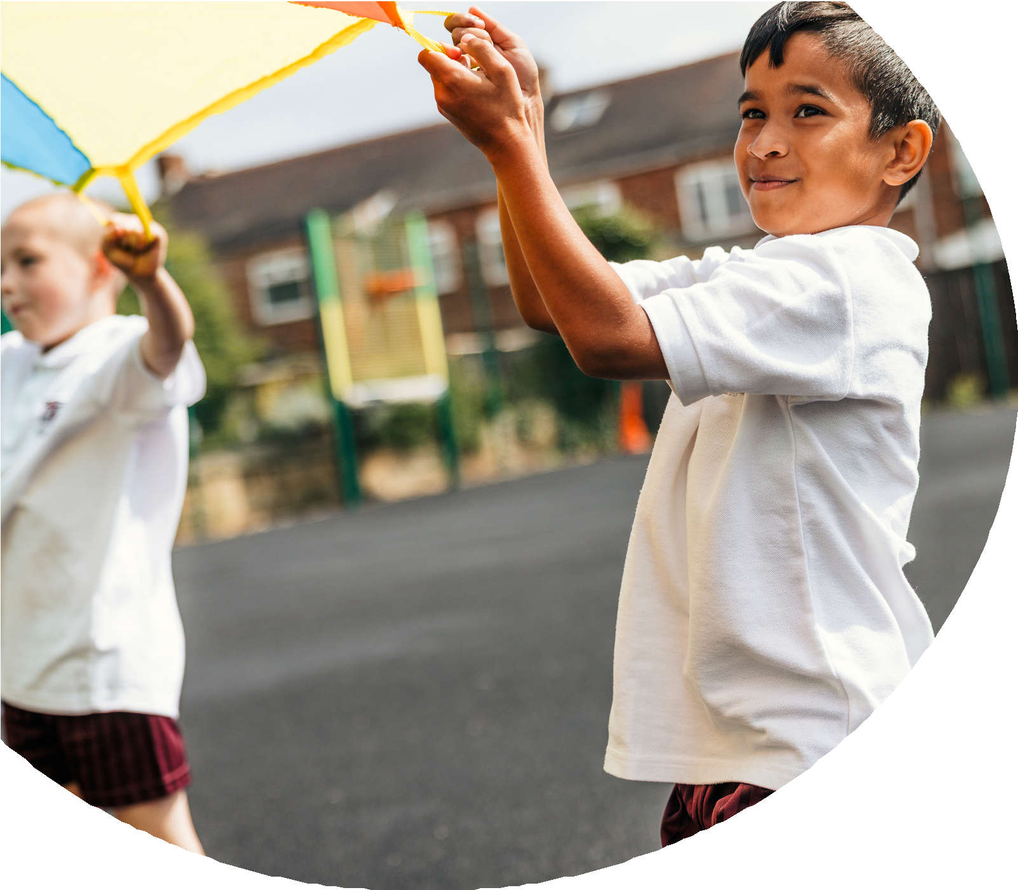
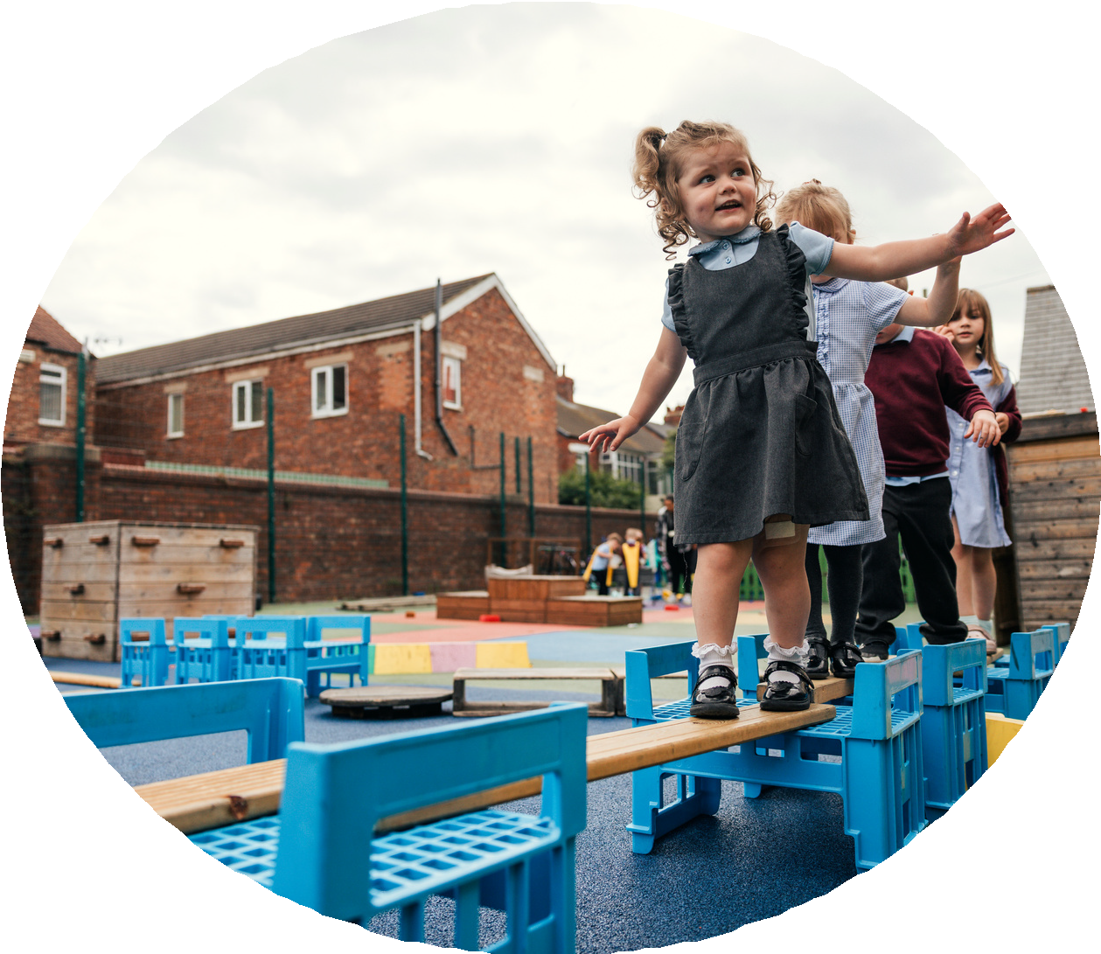

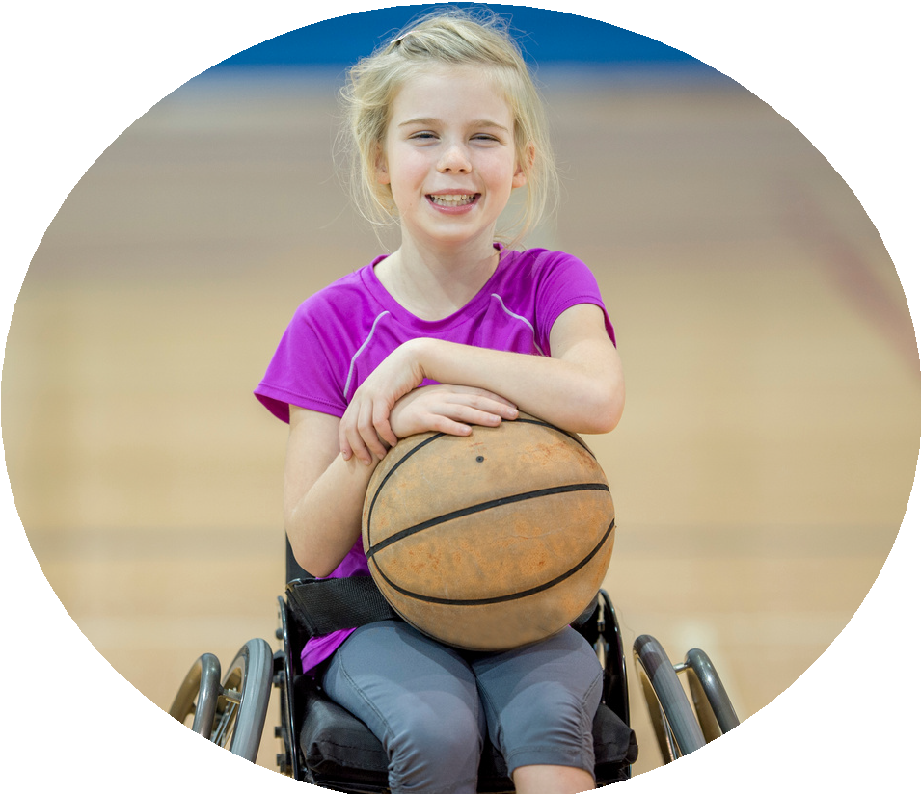



PE and sport premium monitoring and tracking form 2025/2026

Commissioned by

Created by


PE and sport premium monitoring and tracking form
- It is intended that this template should be used as preparation for the completion of the statutory DfE PE and sport premium digital expenditure reporting return. You can upload data (including swimming) from this template onto this platform once it becomes accessible.
- The template is a working document that you can amend and update during the year.
- Before you decide how you are going to use the funding for this academic year you should reflect and evaluate the impact of your use of you PE and sport premium funding in 2024/25.
- You should use your evaluation of last year’s funding to help you decide what to do this academic year, how you will do it, and what impact you expect it to have.
- All spending of the funding must conform with the terms outlined in the conditions of grant
- The summative digital expenditure reporting from June 2026 will continue to include swimming and water safety information. PE and sport premium funding can be used to provide top-up lessons, where necessary, to ensure pupils meet national curriculum swimming requirements
- To ensure funding is used effectively and based on your school’s needs; guidance and examples of best practice across schools can be found here.
- You must use the funding to make additional and sustainable improvements to the PE and sport in your school.
- You must develop and add to the PESSPA activities that your school already offers.

Useful Links:
- PE and sport premium for primary schools - GOV.UK
- PE and sport premium: conditions of grant 2025 to 2026 - GOV.UK
- It is intended that this template should be used as preparation for the completion of the statutory DfE PE and sport premium digital expenditure reporting return. You can upload data (including swimming) from this template onto this platform once it becomes accessible.
- The template is a working document that you can amend and update during the year.
- Before you decide how you are going to use the funding for this academic year you should reflect and evaluate the impact of your use of you PE and sport premium funding in 2024/25.
- You should use your evaluation of last year’s funding to help you decide what to do this academic year, how you will do it, and what impact you expect it to have.
- All spending of the funding must conform with the terms outlined in the conditions of grant
- The summative digital expenditure reporting from June 2026 will continue to include swimming and water safety information. PE and sport premium funding can be used to provide top-up lessons, where necessary, to ensure pupils meet national curriculum swimming requirements
- To ensure funding is used effectively and based on your school’s needs; guidance and examples of best practice across schools can be found here.
- You must use the funding to make additional and sustainable improvements to the PE and sport in your school.
- You must develop and add to the PESSPA activities that your school already offers.

Useful Links:
Complete the PE and sport premium expenditure reporting return - GOV.UK
PE and sport premium for primary schools - GOV.UK
PE and sport premium: conditions of grant 2024 to 2025 - GOV.UK

Review of the last academic year (2024/2025)

Swimming and Water Safety | What went well? Supporting evidence? | What didn't go well? Supporting evidence?
1. Swim competently, confidently and proficiently over a distance of at least 25 metres | N/A did not have KS2 pupils
2. Use a range of strokes effectively (for example, front crawl, backstroke and breaststroke) | N/A did not have KS2 pupils
3. Perform safe self-rescue in different water-based situations | N/A did not have KS2 pupils
- Take some time to reflect on your intent, implementation and impact from last academic year to celebrate your wins but to also think about improvements for the year ahead.
- You do not need to complete every box. Just record the information that is key to your school's priorities and areas of focus.
Remember - Be clear about how you focussed spending on key groups such as SEND, girls and disadvantaged pupils.

Review of the last academic year (2024/2025)
Key areas as outlined in PE and sport premium guidance | What went well? Supporting evidence? | What didn't go well? Supporting evidence?
1. Increasing confidence, knowledge and skills of all staff in teaching PE and sporting activities prioritising CPD and training where needed | All teachers well equipped and confident to lead PE sessions. Only school staff are used to teach PE and not sports coaches.
2. Increasing engagement of all pupils in regular physical activity and sporting activities | All pupils fully take part in PE and other opportunities/
3. Raising the profile of PE and sport across the school, to support whole school improvement | PE is an important part of our curriculum.
4. Offer a broader and more equal experience of a range of sports and physical activities to all pupils and ensure equal access to sport for boys and girls | All activities have equal access to both boys and girls
5. Increasing participation in competitive sport | Intra house competitions have started,

Aims for the next academic year (2025/2026)
- Using your whole school priorities, school development plan and previous PE, school sport and physical activity data, set out your aims for the year ahead.
- Think about specific areas of need such as inactive girls, SEND and disadvantaged pupils
- Remember to also input your swimming data and reflections in the table located at the bottom of this page.
- Consider which of the 5 key areas improvements will be focussing on:
- Increasing confidence, knowledge and skills of all staff in teaching PE and sporting activities prioritising CPD and training where needed.
- Increasing engagement of all pupils in regular physical activity and sporting activities
- Raising the profile of PE and sport across the school, to support whole school improvement
- Offer a broader and more equal experience of a range of sports and physical activities to all pupils and ensure equal access to sport for boys and girls
- Increasing participation in competitive sport
Swimming and Water Safety | Input data | Reflections
1. Swim competently, confidently and proficiently over a distance  of at least 25 metres | No swimming as yet – no KS2 children
2. Use a range of strokes effectively  (for example, front crawl, backstroke and breaststroke) | No swimming as yet – no KS2 children
3. Perform safe self-rescue in different water-based situations | No swimming as yet – no KS2 children

Aim | Why? | Key area | Supporting evidence
Continue to develop range of opportunties available at playtime | Continue to develop gross motor control and to provide alternatives that will keep more childrne engaged. | 2 | Pupil voice
To enable children to be come more proficient cyclists | Support school travel and sustainability plan and to develop cycling skills | 2 and 3
To ensure that all staff members (including support staff) are confident supporting learners – particulary those with SEND. | To ensure that our sessions are inclusive and that all children are able to take part. | 1 and 4
To train a member of staff to lead and deliver forest school sessions. | To broaden children’s physical opportunities | 1, 2 and 3
To continue to develop a range of skills | To broaden children’s physical opportunities and enjoyment of activity | 2 and 4

Plan, monitor and evaluate (2025/2026)
- Please aim to use this as a live working document through the year.

- Keep returning to this to evidence adaptations and progress made through the PESSPA opportunities you provide.

- There is no set number of objectives you must have.

- Make as many or as few as you see fit that will support your aims for the year ahead.

- Consider which of the 5 key areas improvements will be focussing on:
- Increasing confidence, knowledge and skills of all staff in teaching PE and sporting activities prioritising CPD and training where needed.
- Increasing engagement of all pupils in regular physical activity and sporting activities
- Raising the profile of PE and sport across the school, to support whole school improvement
- Offer a broader and more equal experience of a range of sports and physical activities to all pupils and ensure equal access to sport for boys and girls
- Increasing participation in competitive sport

Plan, monitor and evaluate (2025/2026)
Further improve playtimes

 | Intent – what is your objective? | Implementation - How will you achieve this? | Impact - What do you hope to see? | Supporting evidence
Plan and monitor | Continue to develop range of opportunties available at playtime. Further develop staff knowledge of games and activities that could be modelled at playtime. | Purchase and model a wide range of open ended resources to provide a range of physical opportunities at playtimes. Provide training to staff. | A happier, more active playground that meets the needs of all pupils especially SEND and girls. | Pupil voice  Playtime observations and feedback
 | What impact have you seen? | Are the improvements sustainable? How? | Supporting evidence | Approx. cost
Evaluate |  |  |  | £4475

Further develop children’s cycling proficiency
 | Intent – what is your objective? | Implementation - How will you achieve this? | Impact - What do you hope to see? | Supporting evidence
Plan and monitor | To ensure that children are proficient on balance bikes and scooters. | Training sessions for balance bikes and scooters align with objectives. Identify times for cycling and scooter training within school. | Raise the profile of active travel | Pupil voice  Observation of sessions
 | What impact have you seen? | Are the improvements sustainable? How? | Supporting evidence | Approx. cost
Evaluate |  |  |  | £1000

Continue to develop staff proficiency in teaching and leading PE
 | Intent – what is your objective? | Implementation - How will you achieve this? | Impact - What do you hope to see? | Supporting evidence
Plan and monitor | All staff will be continue to be confident to deliver and lead highly engaging and purposeful PE sessions that are expertly scaffolded for pupils with SEND as appropriate. | Continue to use PE hub scheme to support teacher understanding. Experienced PE lead from DPA to be released to support knowledge and understanding to scaffold learning for pupils with SEND. | Highly trained teachers and support staff leading high quality lessons in PE where all pupils are involved. | Lesson observations  Discussion with staff
 | What impact have you seen? | Are the improvements sustainable? How? | Supporting evidence | Approx. cost
Evaluate |  |  |  | PE Hub £1000  Release time for PE Lead £1500

Further develop the range of physical opportunities that are available at SHPA
 | Intent – what is your objective? | Implementation - How will you achieve this? | Impact - What do you hope to see? | Supporting evidence
Plan and monitor | To have a whole school scheme in place for Forest school | Train a member of staff as a Level 3 Forest school leader. Once trained, identify time within the curriculum for Forest school ensuring that sessions are high quality. | A highly trained leader who is able to deliver high quality sessions for all pupils (including those with SEND) | Discussions with staff member  Observations of sessions when they start.
 | What impact have you seen? | Are the improvements sustainable? How? | Supporting evidence | Approx. cost
Evaluate |  |  |  | Cost of course and release time £6000  Resources for forest school £4000

Inspire pupils to try new sports

 | Intent – what is your objective? | Implementation - How will you achieve this? | Impact - What do you hope to see? | Supporting evidence
Plan and monitor | To expose children to a range of physical opportunities | Identify and book a range of experiences that will inspire and further develop children’s physical abilities. | Children take part in a range of different activities: circus skills, skipping workshop etc. Have some resources replicated for use at playtimes. | Observations
 | What impact have you seen? | Are the improvements sustainable? How? | Supporting evidence | Approx. cost
Evaluate |  |  |  | £2000

This page has been left blank for any notes or supporting information.

